Medical Triage System using NLP
1. Problem Statement
A health-tech startup wants to build an intelligent triage assistant that can automatically route patient symptom descriptions to the appropriate medical department such as General, Cardiology, Neurology, or Orthopaedics.
The challenge is to design a machine learning model that can understand natural language symptom descriptions and classify them accurately, while also considering the risks of incorrect predictions in a medical context.
2. Objective
- Build a multi-class text classification model
- Classify symptoms into:
  - General
  - Cardiology
  - Neurology
  - Orthopaedics
- Ensure:
  - Good performance (F1-score)
  - Understanding of model limitations
  - Responsible AI practices
3. Requirements
Functional Requirements:
- Accept symptom text as input
- Predict the correct medical department
- Handle multiple symptom patterns
Non-Functional Requirements:
- Model should be interpretable
- Avoid bias in classification
- Must highlight risks of incorrect predictions
4. Approach
We followed a machine learning pipeline approach:
- Dataset Creation
  - Created synthetic dataset (200 samples)
  - Balanced across all departments
- Data Preprocessing
  - Text cleaned and structured
  - Converted into numerical format using TF-IDF
- Model Training
  - Used Logistic Regression classifier
  - Trained on TF-IDF features
- Model Evaluation
  - Used per-class F1-score
  - Checked accuracy and class-wise performance
- Error Analysis
  - Identified high-confidence wrong predictions
  - Analyzed model weaknesses
- Responsible AI
  - Documented risks and limitations using a model card
5. System Architecture
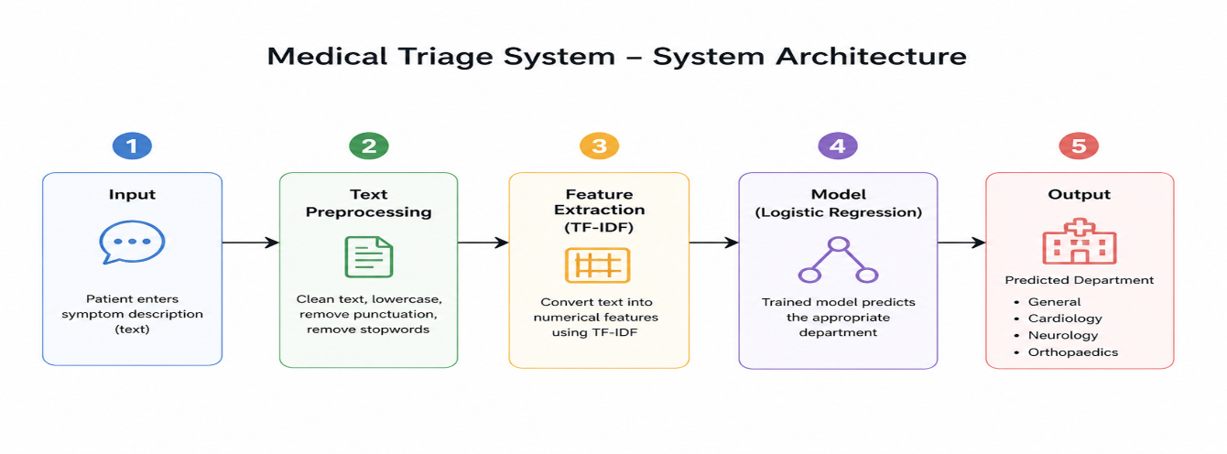
Explanation:
- Input Layer
  - User provides symptom text
- Text Processing
  - TF-IDF converts text → numerical vectors
- Model Layer
  - Logistic Regression processes features
- Prediction Layer
  - Outputs predicted department
6. Technologies Used
- Python
- Pandas
- Scikit-learn
- TF-IDF Vectorizer
- Logistic Regression
7. Results
- Achieved ~88% accuracy
- Good performance across most classes
- Lower recall observed in Neurology
- Identified misclassification patterns
8. Key Findings
- Model relies on keyword patterns rather than deep understanding
- Overlapping symptom descriptions can cause confusion
- Data quality significantly affects performance
9. Limitations
- Synthetic dataset (not real medical data)
- Limited vocabulary
- Cannot understand complex medical context
- Misclassification risk exists
10. Conclusion
The model successfully demonstrates a basic NLP-based triage system capable of classifying symptom descriptions into medical departments. However, due to its limitations, it should be used only as a supportive tool and not as a standalone decision-making system in real-world healthcare.
11. Future Improvements
- Use real-world medical datasets
- Apply advanced models (BERT, Transformers)
- Improve dataset diversity
- Add human-in-the-loop validation

